

Project Name: Ayakshm Health-Care Management System

Branch C-DAC Sept-2022

Documentation On

**“**Ayakshm Health-Care Management System**”**

E-DAC SEPT 2022

**Guided By: Prathamnesh Nike**

Submitted By :

**Group No: 10**

* **Ajay Bhosle 220943020002**
* **Atharv Suryavanshi 220943020009**
* **Gaurav Urkude 220943020027**
* **Saurabh Potdukhe 220943020082**

**Table of Contents**

**1. Introduction 4**

1.1 Document Purpose **4**

1.2 Project Background **4**

1.3 Aim & Objectives **4**

**2. Business Requirements Overview**…………………………………………………………**5**

**3.Functional Requirements** **6**

3.1 Patient Module **6**

3.2 Doctor Module **6**

3.3 Hospital Module **6**

3.4 Admin Module **6**

**4.** **Non-Functional Requirement………………………………………………………………7**

**5. Use Case Diagram 8**

5.1 Admin **9**

5.2 Patient **10**

5.3 Doctor **11**

5.4 Admin **12**

**6. Database Design 12**

1 User **12**

2 Admin **12**

3 Patient…………………………………………………………………………………… **13**

4 Doctor **13**

5 Hospital **13**

**7. E-R Diagram………………………………………………………………………………………14**

**8. Snapshots 15**

**9. Conclusion 20**

**List of Figures**

**Use Case Diagrams 17**

Fig 1 Admin 8

Fig 2 Patient **10**

Fig 3 Doctor **11**

Fig 4 Admin **12**

Fig 5 ER Diagram 14

1. **Introduction:**
   1. **Document Purpose:**

This document communicates the business requirements and scope for developing The Healthcare Management System. The scope of this document is to define the functional and non-functional requirements, business rules and other constraints requirements.

There is no system available which can manage the facilities of the hospitals and connect them with the doctors and patients efficiently. From patients’ perspective it is hard for them to find hospitals, doctors, treatments and some particular medicines and to compare between them. It is also difficult to find an available bed at the hospitals in the vicinity. Also, carrying all the medical records in hard copy related to a treatment is difficult.

For doctors, it is hard to treat the patient if they don’t know the medical history of that patient. There is also a difficulty for doctors to consult with each other or with an expert on a complex treatment. For hospitals, they cannot interact with patients about the availability of beds and treatments as well as specialist doctors who practice there for a limited period of time.

Because of these points, there is no efficient interaction between the patients, the doctors and the hospitals. We have experienced this mis-interaction in the last few years when the COVID-19 pandemic was ongoing.

## Project Background:

In this pandemic, one of the main things the whole world has understood is power of internet and as need of internet. During this pandemic, Health-Care systems in India faced lot of challenges. With this challenge in mind, we decided to work on a system where we can completely virtualized or make the health-care process such as online booking doctors appointment, searching hospitals and various treatments etc.

## Aim & Objectives:

The main objective of this project is building a website which can increase the interaction between patients, doctors and hospitals. Supposing the patients have the knowledge of computers and the internet, they can easily find hospital facilities and treatments. They also can find medicines, medical equipment, blood banks etc. Also finding the basic fees of doctors and comparing them is easy. On the other side, doctors and hospitals can also manage their requirements according to patients. Data about the available facilities can be visible to the patients.

**Scope**:

1. Hospital Management will be able to give information about bed availability as well as treatment facilities and doctors related to them.
2. The System will be operational 24 x 7.
3. This system will be operational in cities of Maharashtra state.
4. Information about patient will be taken by patient sign up. Whenever the patient comes up, their information is stored freshly.
5. Patient can check treatment info quality of facility, and basic price for these.
6. Diagnosis information of patient is generally recorded on the system, which contains Patient information. This info can be available to the patient as well as doctors.
7. Bills are generated by recording the price for each facility provided to the patient. This info will be saved and will be summed up at the end.
8. Doctor’s information will be taken by doctor sign up. This info will be provided by doctor and validated by hospital management.
9. Treatments with their full info which are given by each doctor will be saved and can be used for patient’s further treatments.
10. Hospitals will be given access to the system by Admin. This can be done through validation and legal check. All the info about the whole system will be controlled by Admin.
11. **Business Requirements Overview**

* Healthcare Management System is a public web application.
* Healthcare Management System will be opened to the global, but in the phase 1, the main targets are medical facilities in the cities of the State of Maharashtra.
* There are mainly three types of users. First is civilians(patients), second is doctors and third is hospital administration.
* Patients can search for medical services and medical products.
* Doctors can search for the medical history of a patient.
* Hospitals can show available services, treatments, doctors and medical resources.
* Healthcare Management provides the functionality which connects patients, doctors and hospitals efficiently.
* The Healthcare Management System could be maintained by the Admin.

# Functional Requirements Overview:

Aykashm Health-care Management System consists of four modules described as below.

1. Patient Module
2. Doctor Module
3. Hospital Module
4. Admin Module

# **3.1 Patient Module**

* Patient can register and create his own account.
* They are able to browse treatments and facilities.
* Patients can upload and save their medical record in digital format.
* Patient can select doctor and hospital as they see fit.
* Patients will be able to rate the services provided by the hospital.

# **Doctor Module**

* Doctors can register and create their own account individually.
* Healthcare Management System provides the function which allows doctors to review medical records of patients.
* Doctors can also take expert or specialist advice using the system.
* Update or remove option will be provided to doctors if they wanted to change or delete their account.

# **3.3 Hospital Module**

* Hospital Administration will maintain their own account.
* This account can update data about the treatments and hospital beds availability.
* They can be considered to be a link between the patients and the doctors which are being connected through this platform.
* Hospitals will receive government notifications and health sector advancement.

* Add, remove and update options will be given to the Hospital Administration to manage Doctors and Treatments.

# **Admin Module**

* The Healthcare Management System should provide all functions to the admin about how to handle the System i.e. patients, visiting doctors and hospitals.
* Hospital Administrations as well as visiting doctors will be authorized and verified by the admin.
* Admin will be connected to the government health bodies (like ICMR) directly.
* They could know about all the transactions that happen through the system and generate reports.
* Add, remove and update options will be given to the Admin to manage Hospitals and visiting Doctors.

1. **Non-Functional Requirement:**

* The website should use professional design, look and feel and color scheme.
* Users will have no limitations for accessing the application through the Internet. The portal being an internet application, it is difficult to specify exact number of visitors or users. Hence we will target the system to support between 5 and 10 million users on launch of phase 1.
* Being a public website, the site must follow general usability guidelines for menus, navigation, colors, links and other actions provided on the screens.
* The system should be designed in such a manner that users will be able to complete tasks in a minimum number of steps.

## 5. Use-Case Diagram

**5.1 Admin:**

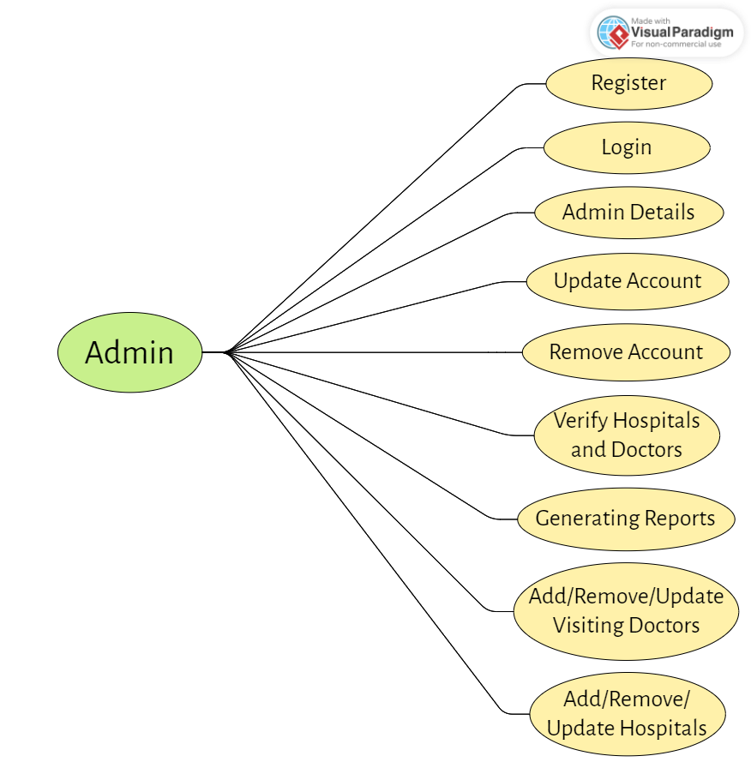

Fig. Use-Case Diagram for Admin

1. In Admin use case diagram Admin is the Actor.
2. Admin can handle following use cases:
3. Register
4. Login
5. Admin Details
6. Update Account
7. Remove Account
8. Verify Hospitals and Doctors
9. Report Generation
10. Add/Remove/Update Visiting Doctors
11. Add/Remove/Update Hospital

## 5.2 Patient:

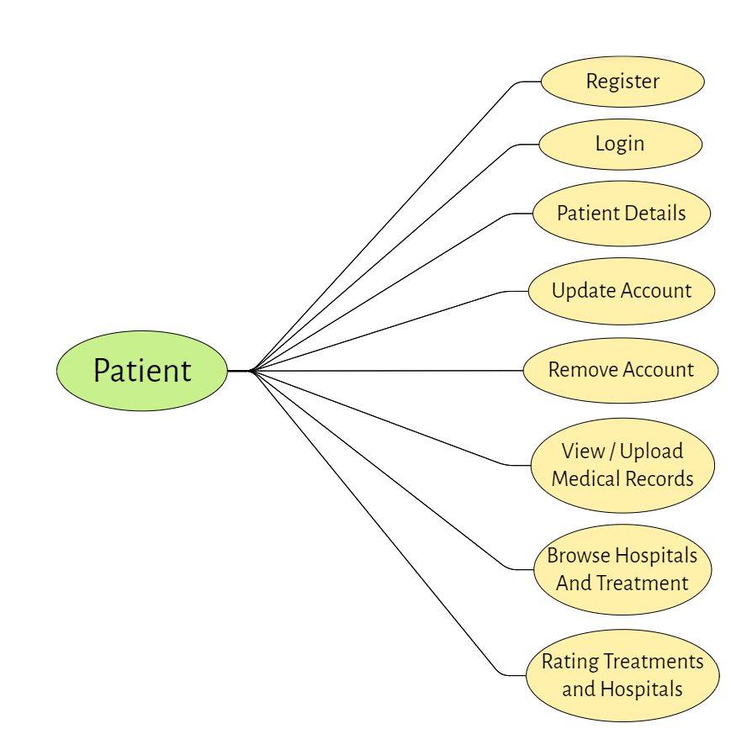

Fig. Use-Case Diagram for Patient

1. In Patient use case diagram Patient is the Actor.
2. Patient can handle following use cases:
3. Register
4. Login
5. Patient Details
6. Update Account
7. Remove Account
8. View/Upload Medical Records
9. Browse Hospitals and Treatments
10. Rating Treatments and Hospitals

**5.3 Doctor:**  
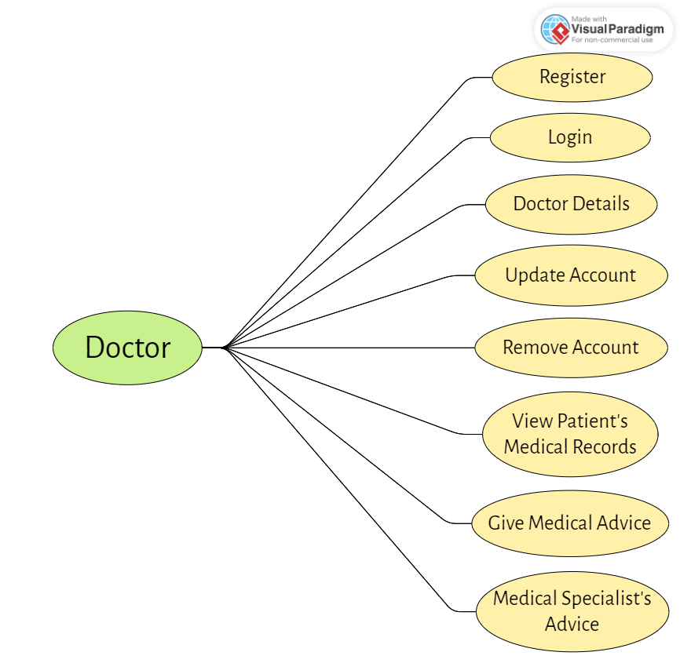

Fig. Use-Case Diagram for Doctor

1. In Doctor use case diagram Doctor is the Actor**.**
2. Doctor can handle following use cases:
3. Register
4. Login
5. Doctor Details
6. Update Account
7. Remove Account
8. View Patient’s Medical Records
9. Give Medical Advice
10. Medical Specialist’s Advice

**5.4 Hospital:**

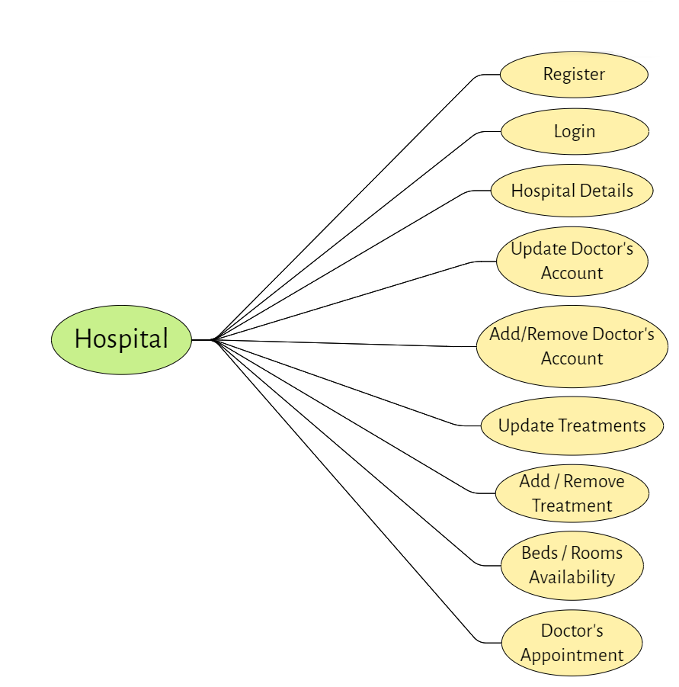

*Fig. Use case diagram for Hospital*

1. In Hospital use case diagram Doctor is the Actor.
2. Doctor can handle following use cases:
3. Register
4. Login
5. Hospital Details
6. Update Doctor Account
7. Add/Remove Doctor Account
8. Update Treatments
9. Add/Remove Treatments
10. Beds/Room Availability
11. Doctor’s Appointment

**6. Database Design:**

**1] Tbl_User**

|  |  |  |  |  |  |
| --- | --- | --- | --- | --- | --- |
| **Field** | **Type** | **Null** | **Key** | **Default** | **Description** |
| Uid | Integer | No | Primary key | Null | User ID |
| Pwd | Varchar(45) | No |  | Null | Password |
| Email | Varchar(45) | No |  | Null | Email ID Of user |
| Uname | Varchar(15) | No |  | Null | User Name |
| Address | LONGTEXT | No |  | Null | Permanent Address |
| Role | Varchar(45) | No |  | Null | Patient/Doctor/Hospital |

**2] Tbl_Admin**

|  |  |  |  |  |  |
| --- | --- | --- | --- | --- | --- |
| **Field** | **Type** | **Null** | **Key** | **Default** | **Description** |
| Aid | Integer | No | Primary key | Not Null | Admin ID |
| Aname | Varchar(45) | No |  | Not Null | Name |
| MobNo | Varchar(10) | No |  | Not Null | Mobile No |
| Uid | Integer | No |  | Not Null | User ID Of User |

**3] Tbl_Patient**

|  |  |  |  |  |  |
| --- | --- | --- | --- | --- | --- |
| **Field** | **Type** | **Null** | **Key** | **Default** | **Description** |
| Pid | Integer | No | Primary key | Not Null | Patient ID |
| Pname | Varchar(45) | No |  | Not Null | Patient Name |
| DOB | DATE | No |  | Not Null | Patient Birth Date |
| MobNo | Varchar(45) | No |  | Not Null | Patient Contact No |
| Gender | Varchar(45) | No |  | Not Null | Patient Gender |
| Uid | Integer | No | Foreign key | Not Null | Reference to Uid (Tbl_User) |

**4] Tbl_Doctor**

|  |  |  |  |  |  |
| --- | --- | --- | --- | --- | --- |
| **Field** | **Type** | **Null** | **Key** | **Default** | **Description** |
| did | Integer | No | Primary key | Not Null | Doctor ID |
| dname | Varchar(45) | No |  | Null | Doctor Name |
| dob | Varchar(45) | No |  | Null | Doctor Date of Birth |
| mobno | Integer | No |  | Null | Mobile Number |
| gender | Varchar(45) | No |  | Null | Doctor Gender |
| uid | Integer | No | Foreign key | Null | Reference to Uid (Tbl_User) |
| degree | DateTime | No |  | Null | Doctors Qualification |
| experience | Integer | No |  | Null | Number of year working experience |
| specialization | Varchar | No |  | Null | Specialized Degree |
| Status | TinyInt | No |  | Not Null | Doctor is active or not |
| hid | Integer | No | Foreign key | Not Null | Reference to Hid (Tbl_Hospital) |

**5] Tbl_Hospital**

|  |  |  |  |  |  |
| --- | --- | --- | --- | --- | --- |
| **Field** | **Type** | **Null** | **Key** | **Default** | **Description** |
| Hid | Integer | No | Primary key | Null | Customer Account Number |
| Hname | Double | No |  | Null | Hospital Name |
| Teleno | Varchar(15) | No |  | Null | Telephone No Of Hospital |
| Status | Varchar(50) | No |  | Null | Hospital is active or not |
| Uid | Integer | No | Foreign key | Null | Reference to Uid (Tbl_User) |

## 7. ER-Diagram:

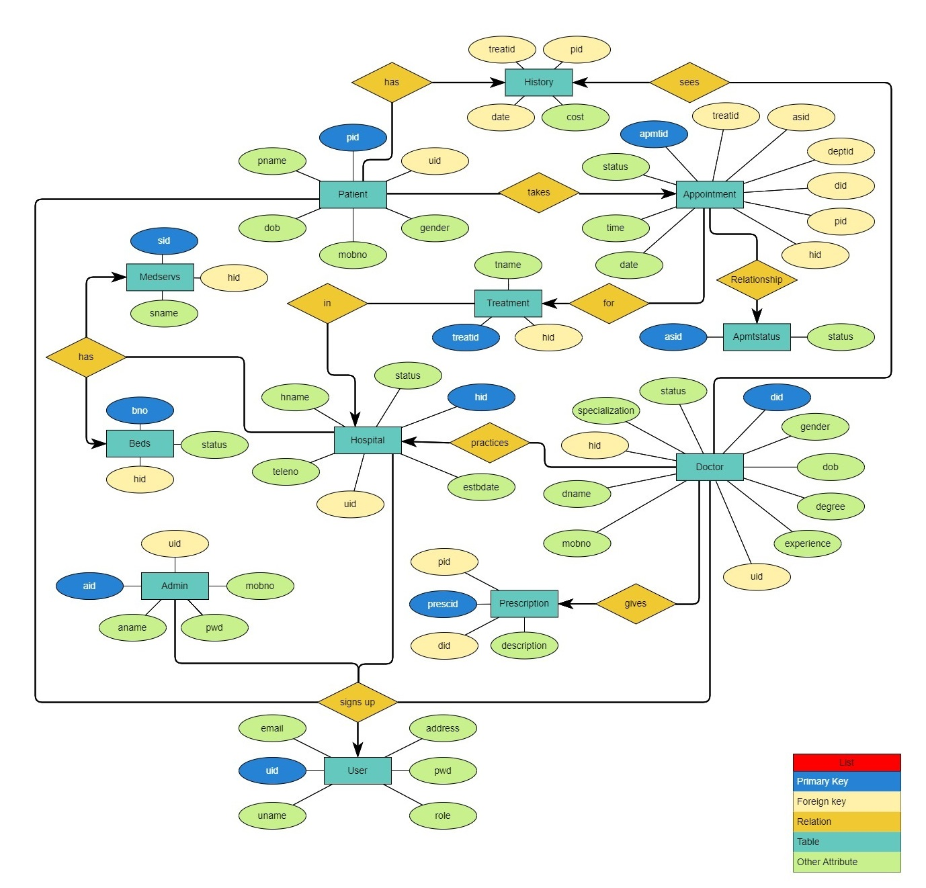

**E-R diagram shows database of Healthcare Management System**

**8. Snapshots:**

**8.1 User Login Page:**

Following snapshot shows the Login page for Ayakshm Health-Care Management System

This page contains following controls

* Home
* Contact
* About
* Login Button

**8.2 Contact Page**

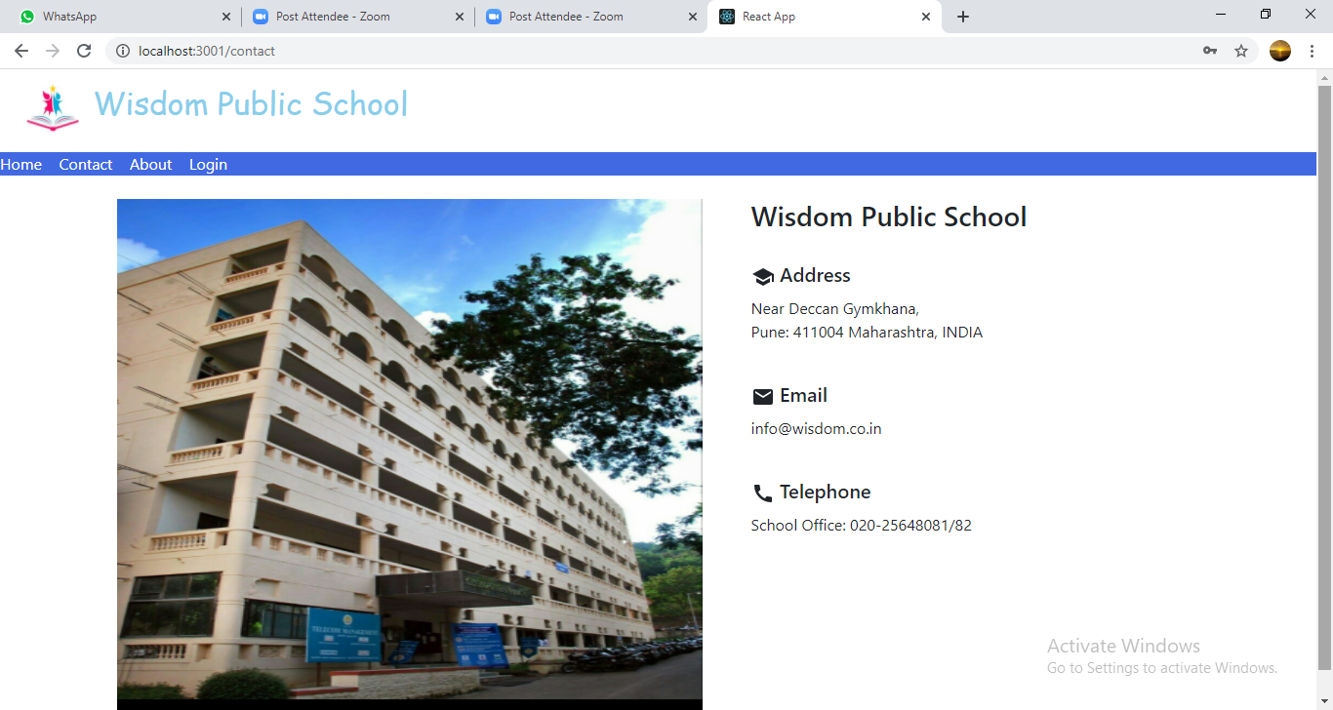

**8.3 About Page**

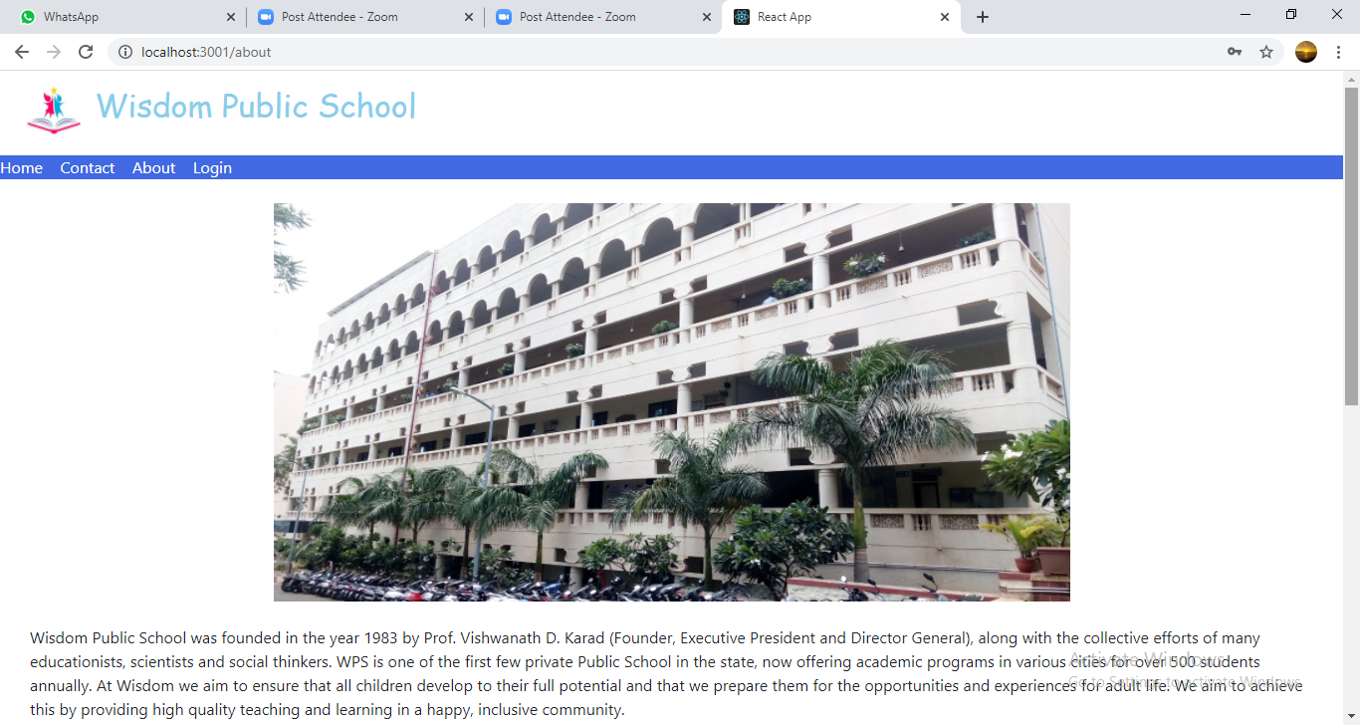

**8.4 Login Page**

Following snapshot shows the Login page for Paperless School Management System

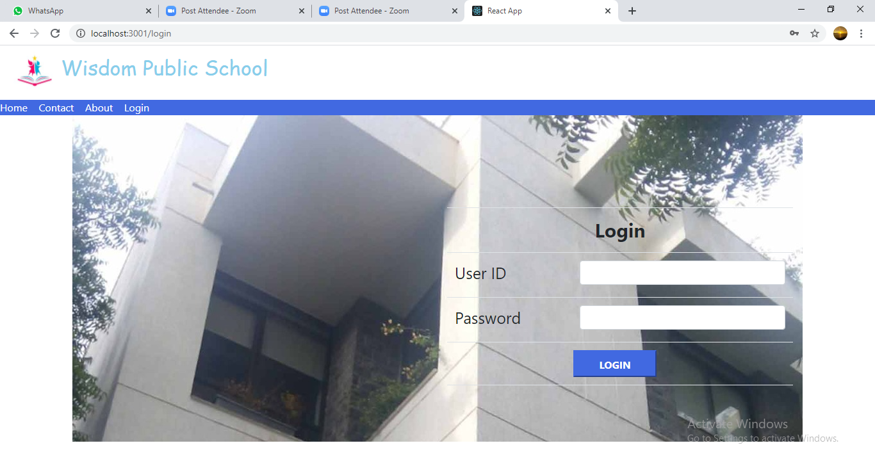

**8.5 Admin Home Page**

**8.5.1 Student Registration Page**

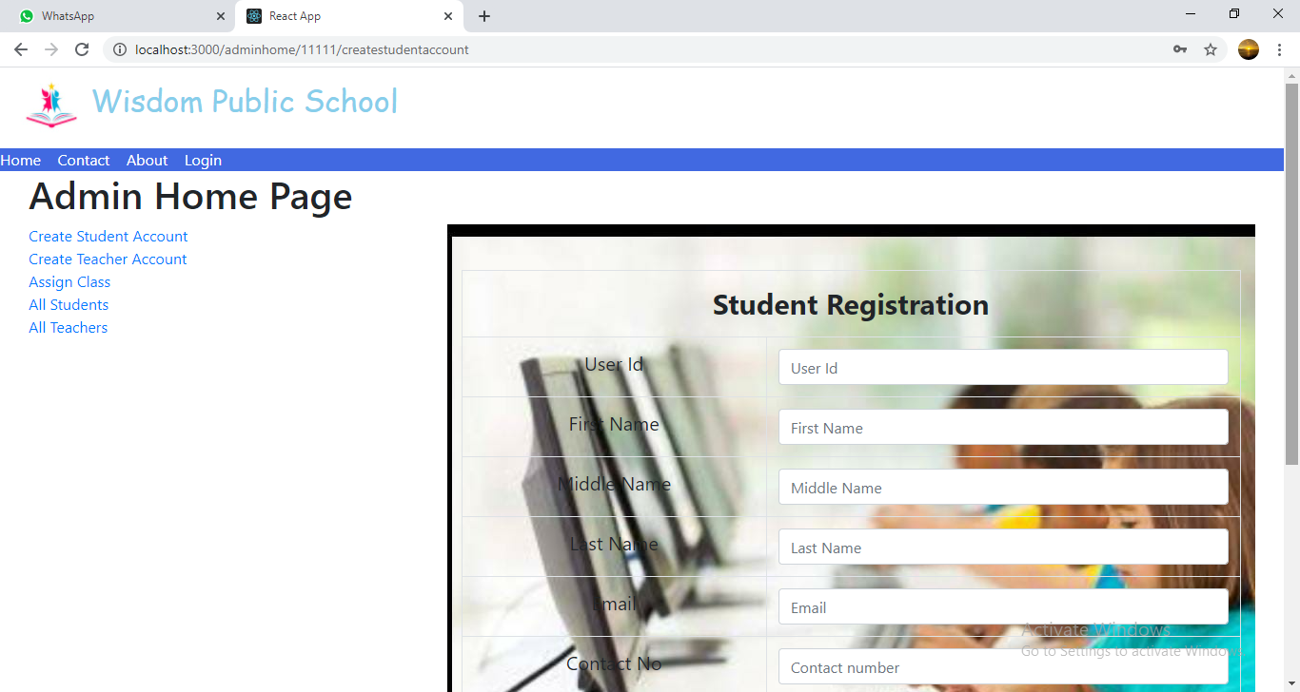

**8.5.2 Teacher Registration Page**

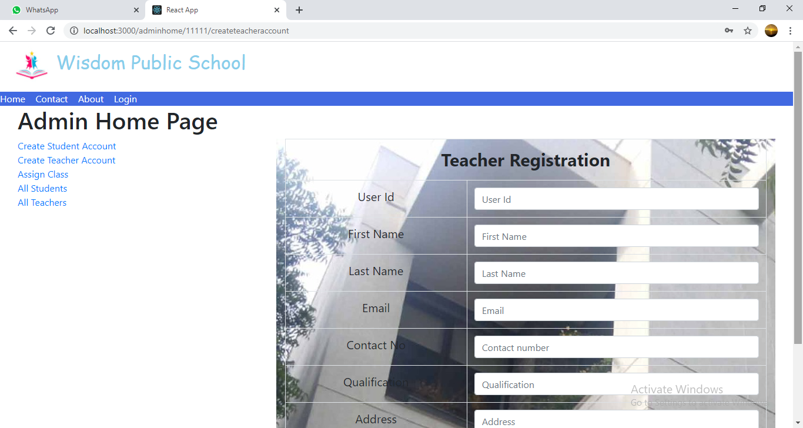

**8.5.3 Assign Class Page**

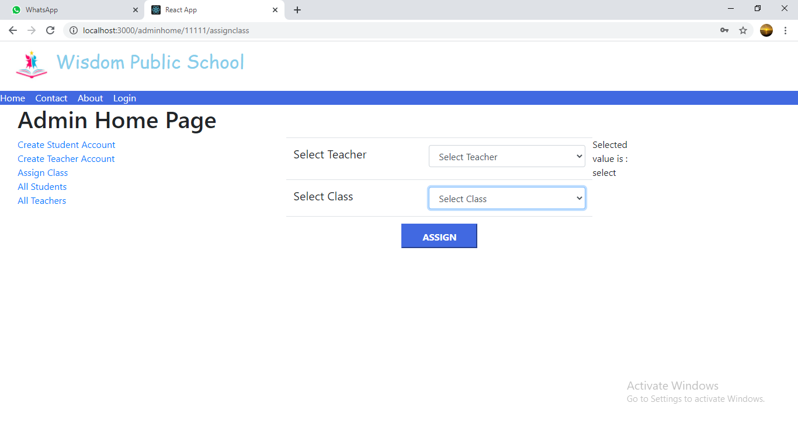

**8.5.4 All Students List**

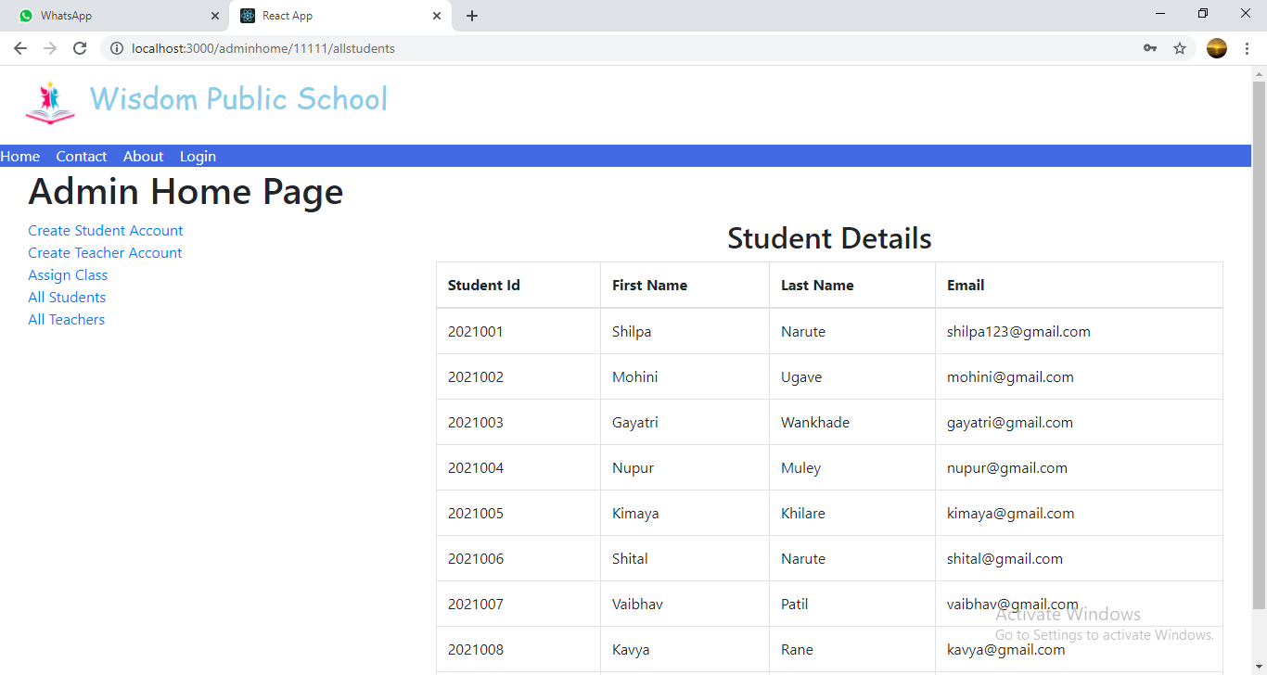

**8.5.5 All Teachers List**

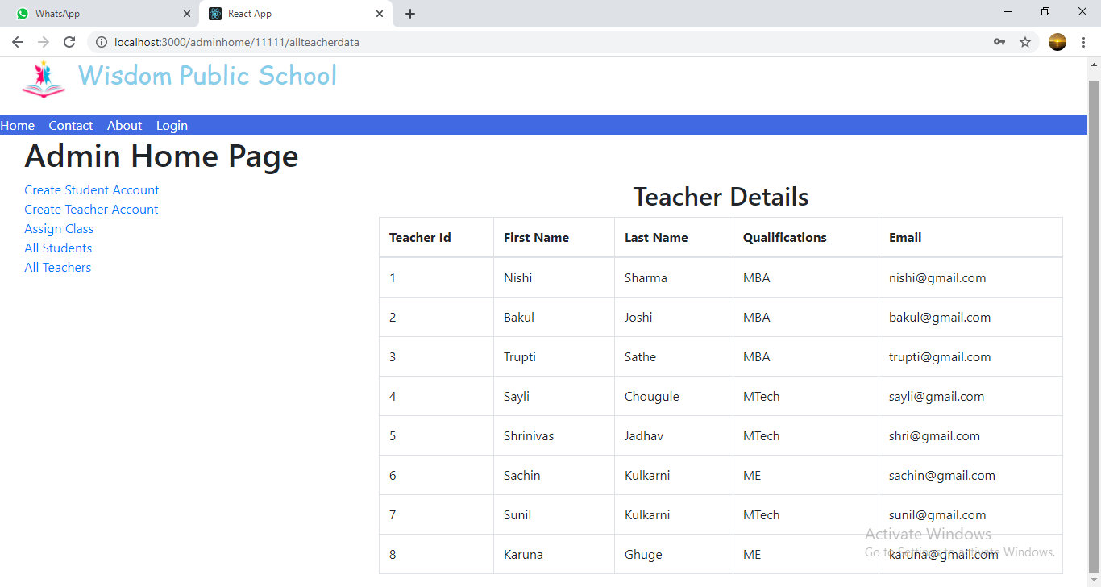

**8.6 Teacher Home Page**

**8.6.1 Upload Study Material Page**

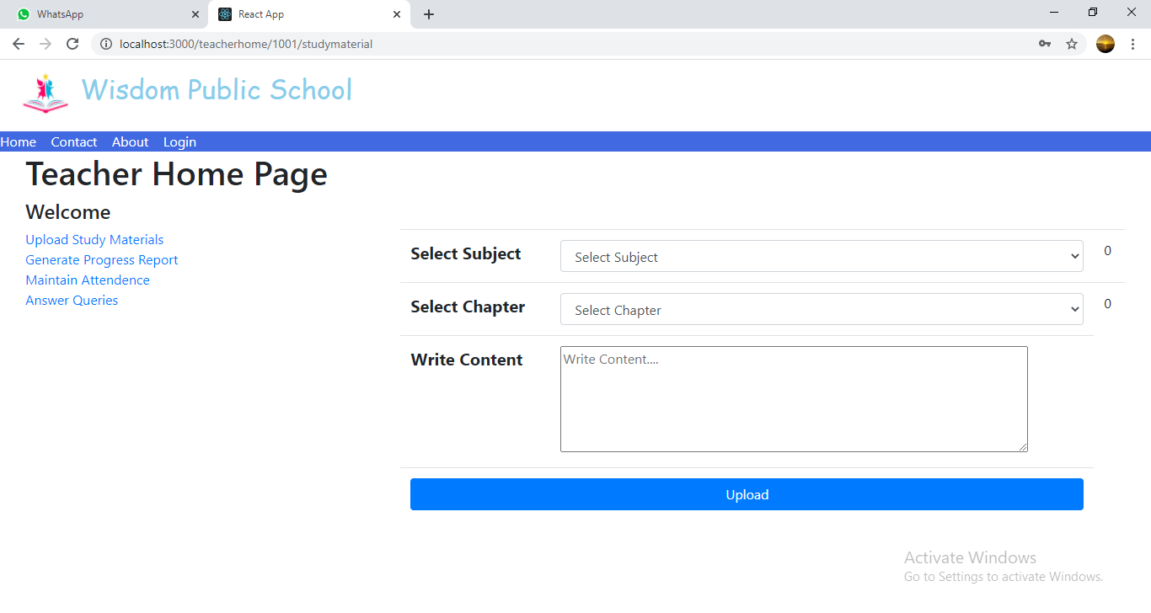

**8.6.2 Generate Progress Report Page**

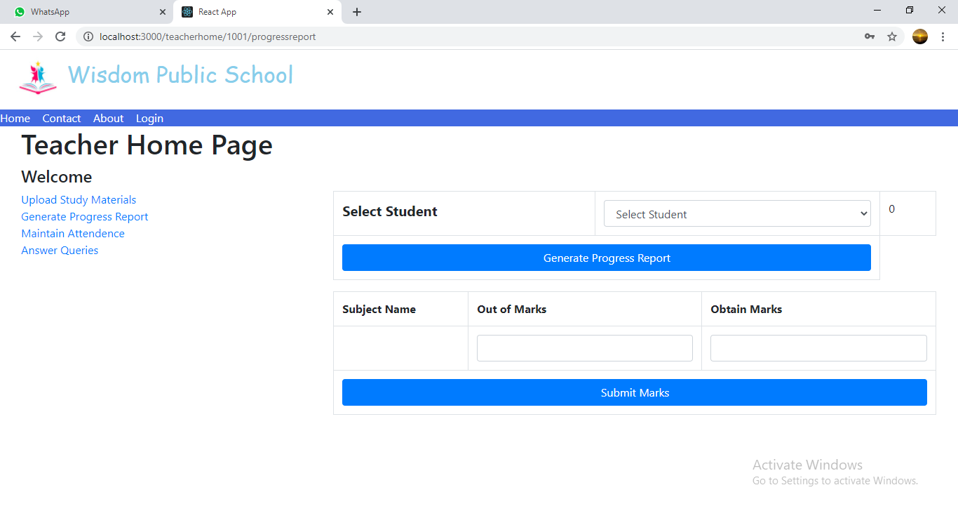

**8.6.3 Maintain Attendance Page**

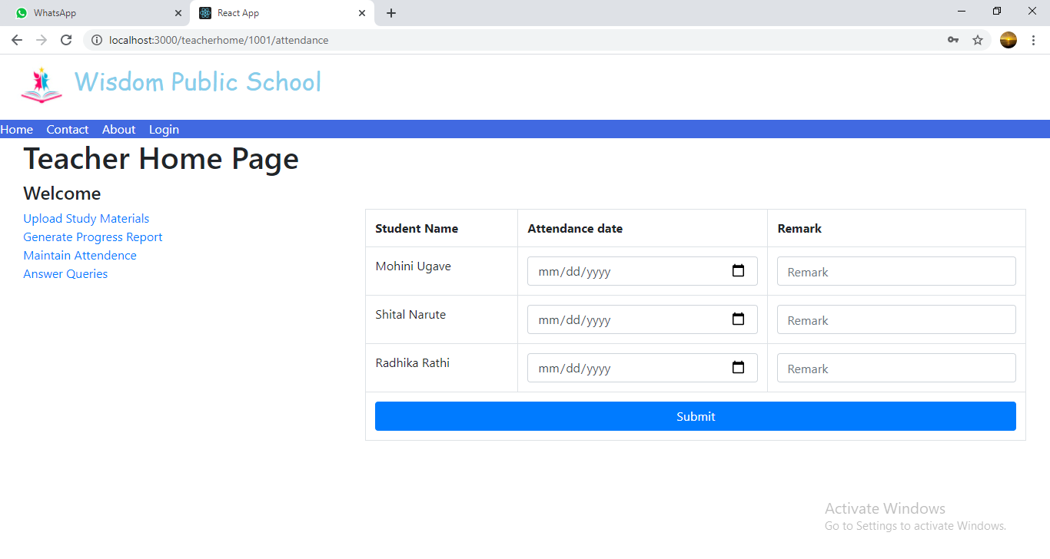

**8.6.4 Answer Queries Page**

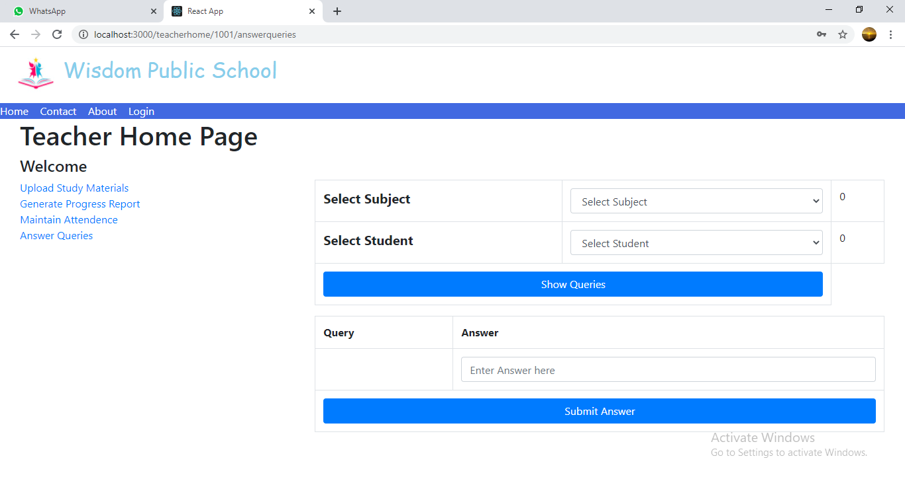

**8.7 Student Home Page**

**8.7.1 View Study Material Page**

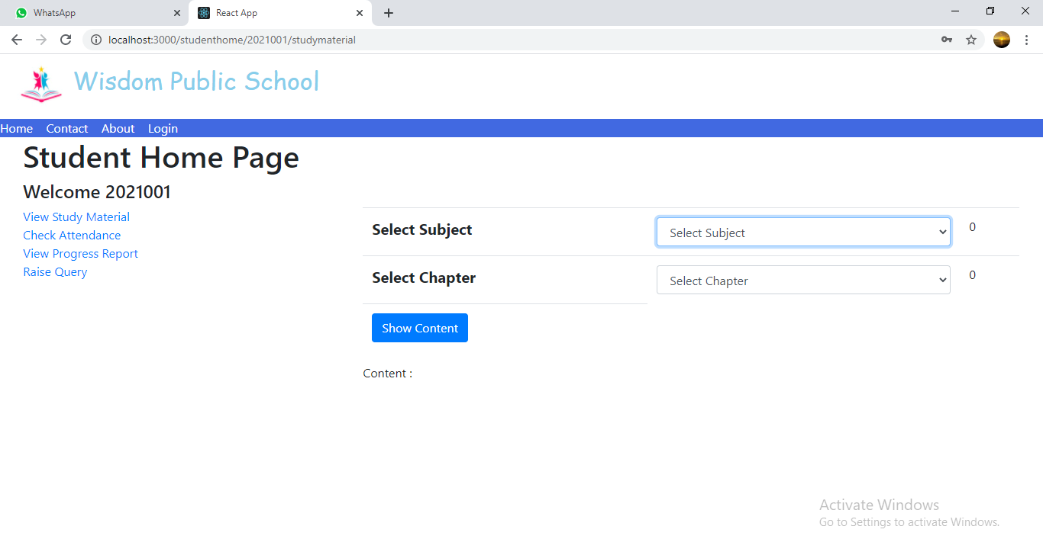

**8.7.2 Check Attendance Page**

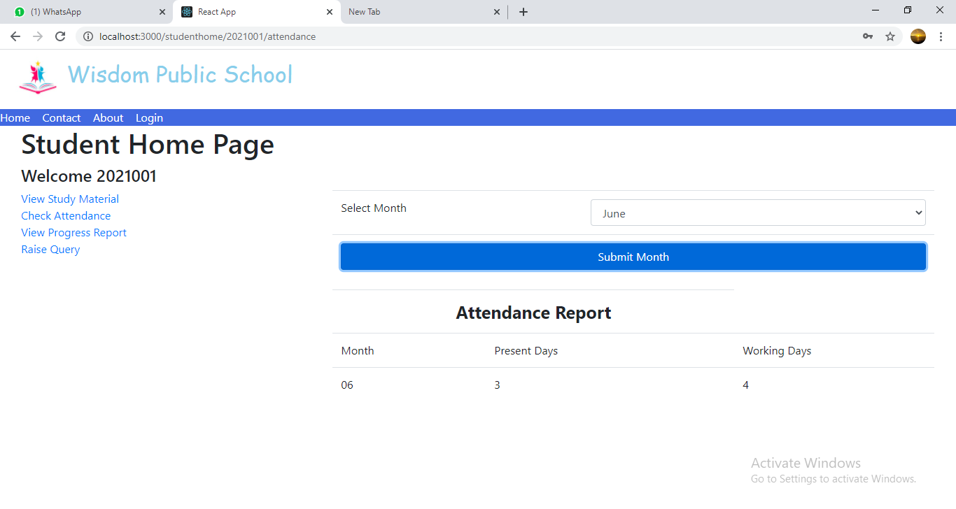

**8.7.3 View Progress Report Page**

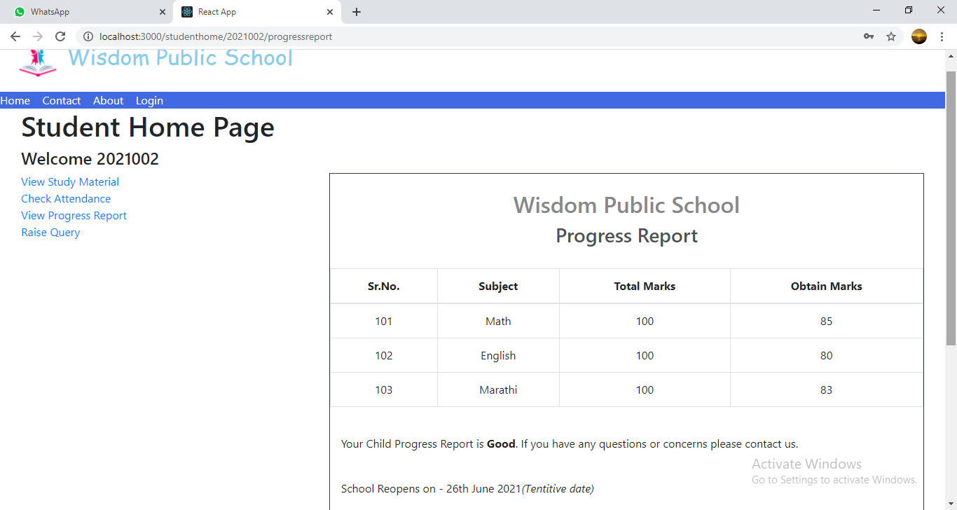

**8.7.4 Raise Query Page**

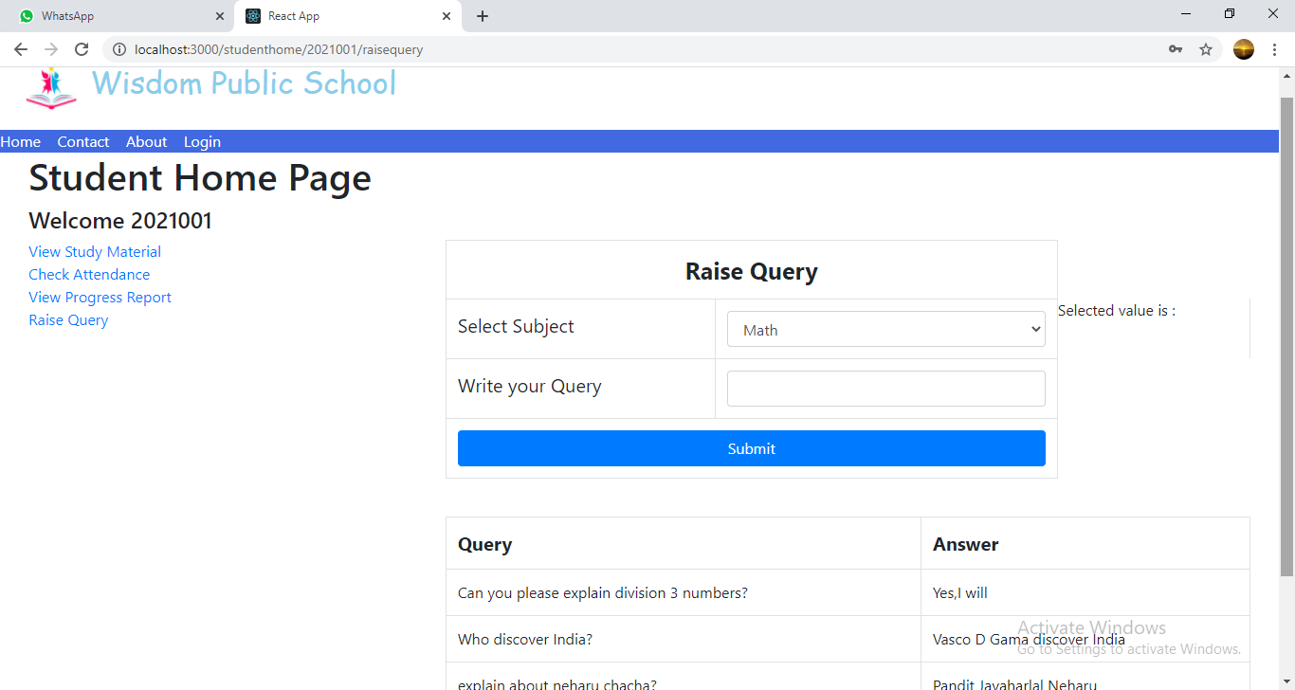

**9. CONCLUSION AND FUTURE SCOPE**

Ayakshm Health-Care Management System provides better education and platform to get connected with Teachers and Students efficiently.

Our System provides a very user-friendly platform where Student can easily read the study materials, check the attendance, raise the queries and view progress report, also Teacher will upload study materials, maintain attendance, answer queries and generate progress report.

Our system is aimed efficient management of various tasks like Generating time table for students on daily basis, Managing fees payment, Examination management. Digitally monitor daily activities along with managing all the resources and information on a single platform.